1. *Display the Employee Name, Job, and Start Date of Employees hired from February 1981 to May 1981.*

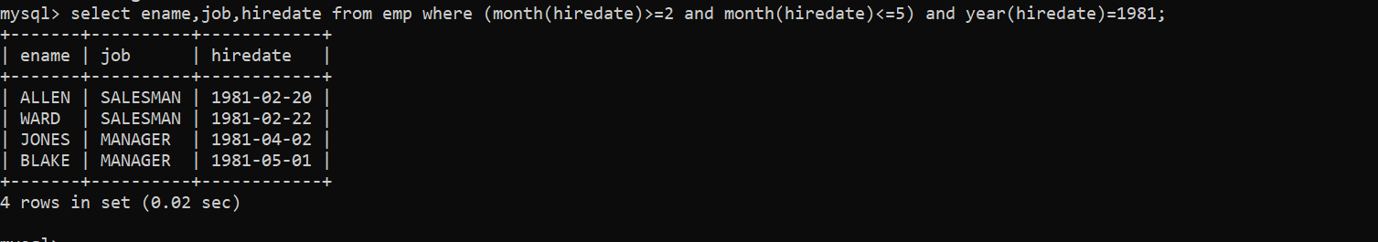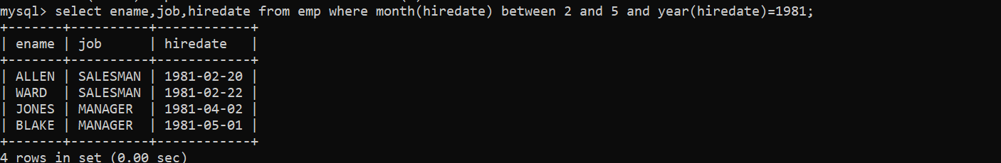

1. *Display the Name and Hiredate of every Employee who was hired in 1982.*

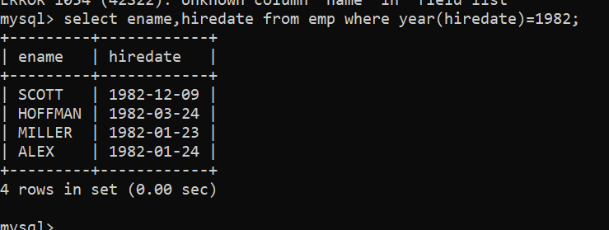

1. *Write a query to display the current date. Label the column as Current Date.*

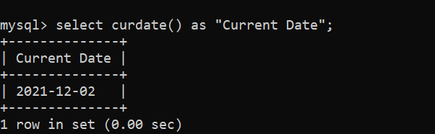

1. *Display the Employee’s Name, Hiredate, Salary and Review Date, which is first Monday after six months of service.*

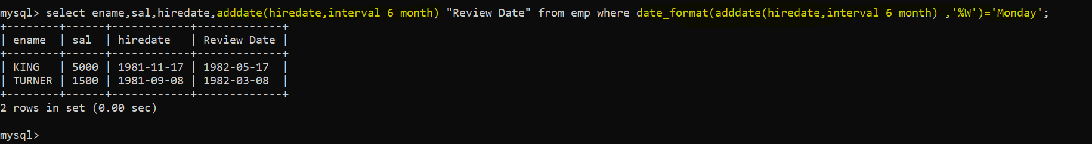

1. *Modify the query to display the dates as “Sunday, the Seventh of September, 1981”.*

select sysdate(),date_format(sysdate()," %W, the %D of %M ,%Y ") ;

1. *Create a query to display the name and salary for all Employees. Format the salary to be 15 characters long by adding ‘$’.*

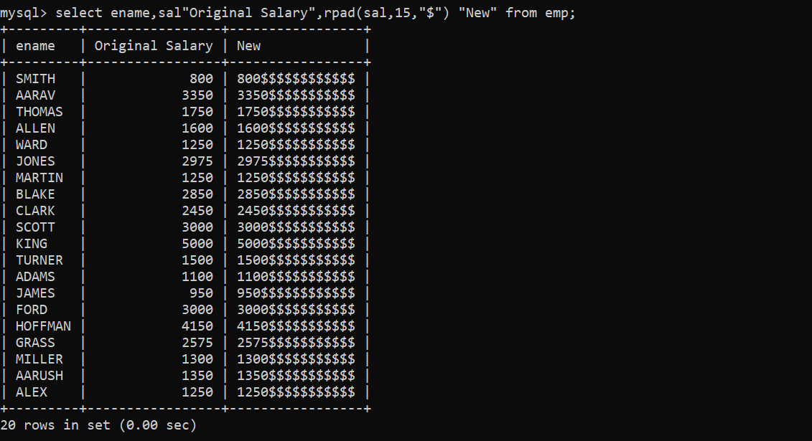

1. *Display the Name, Hiredate and day of the week on which the employees started. Order the results by the Day of the week starting with Monday.*

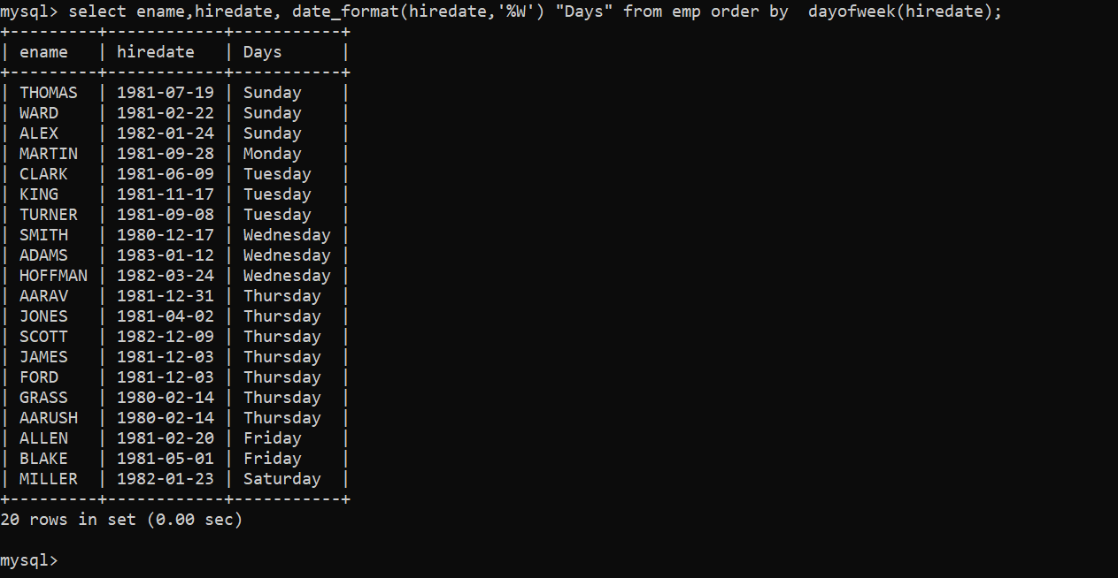

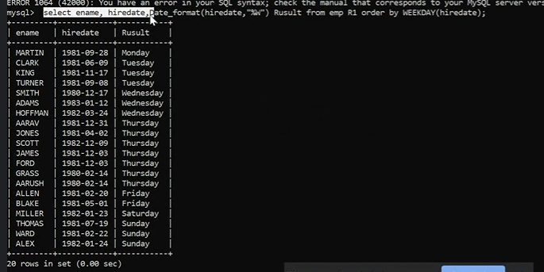

1. *Display details of orders received in the year 1986*

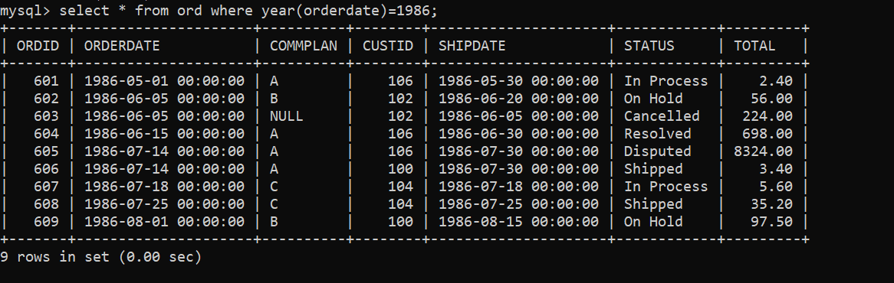*.*

1. *Write a query to find out the DAY (for example, SUNDAY) of the current date.*

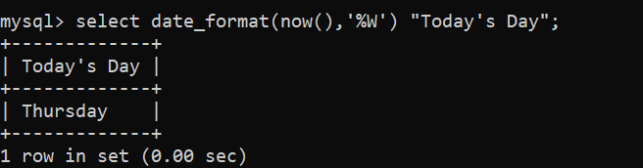

1. *Display the name and the date of joining of the employees who belong to department number 10. The date of joining should be formatted. For eg. if it is ‘10-JUN-97’ it should be displayed as Fifteenth JUNE, 1997. The name of the employee should be in upper case.*
2. *Consider the Ord table. Find the difference between the Order Date and Ship Date in months as well as days. Label the columns appropriately.*

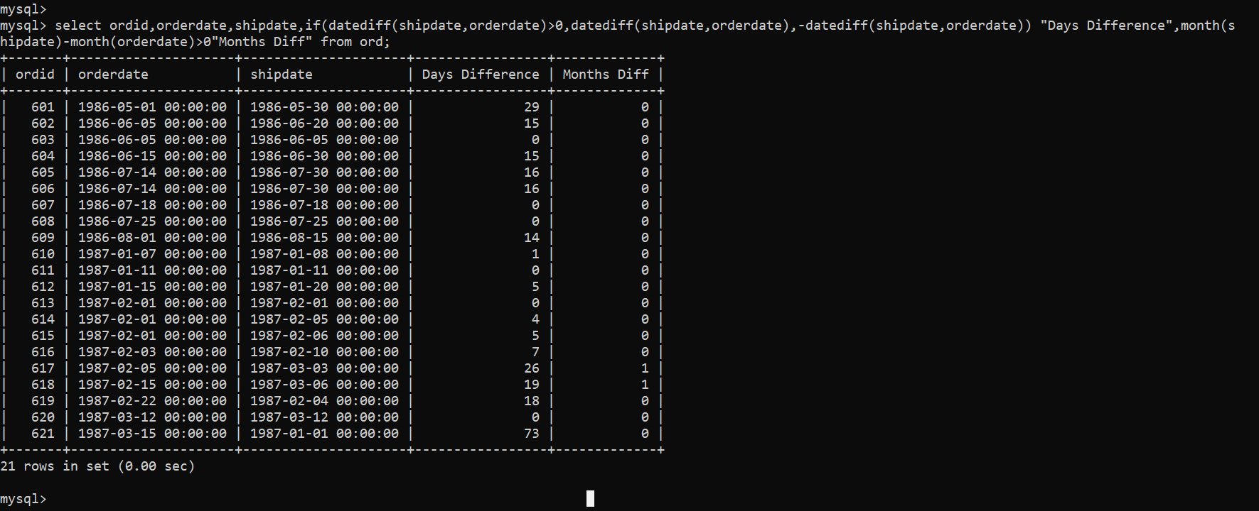

1. *List employee details who have joined in December.*

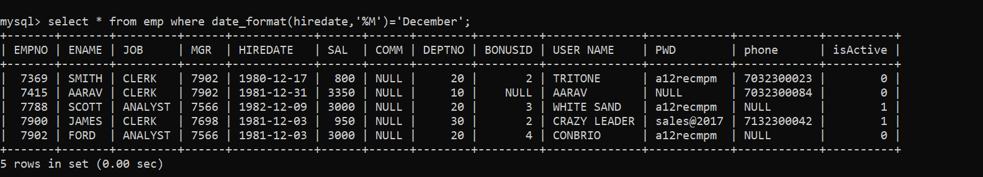

1. *Display day on which KING joined.*

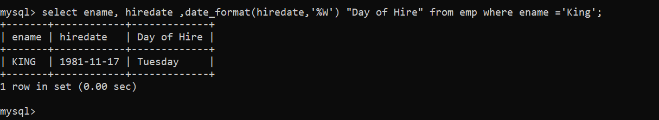

1. *Display month on which MARTIN joined.*

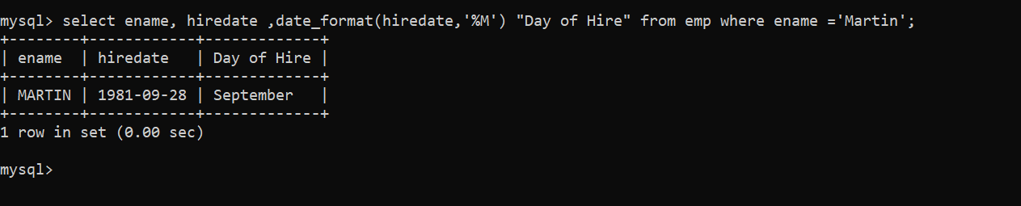

1. *Find number of days elapsed between today’s date and hiredate of ‘ADAMS’.*

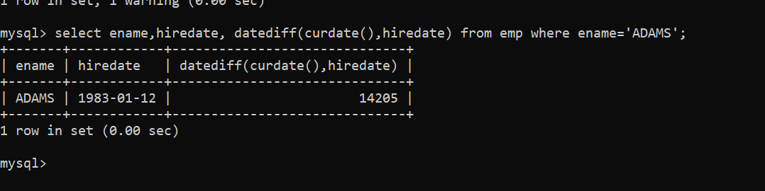

1. *Print the date, 15 days alter today’s date.*

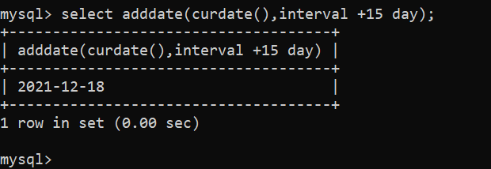

1. *List all employee hired in the month of December.*

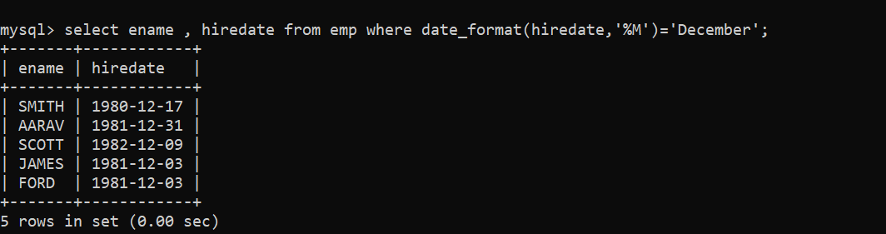

1. *List all employee hired after 1980.*

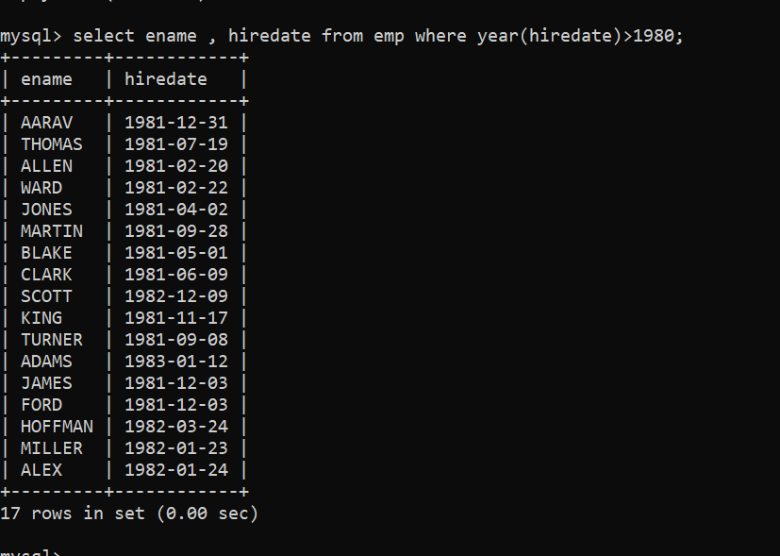

1. *Display names and jobs of employee in the format SMITH-CLERK.*

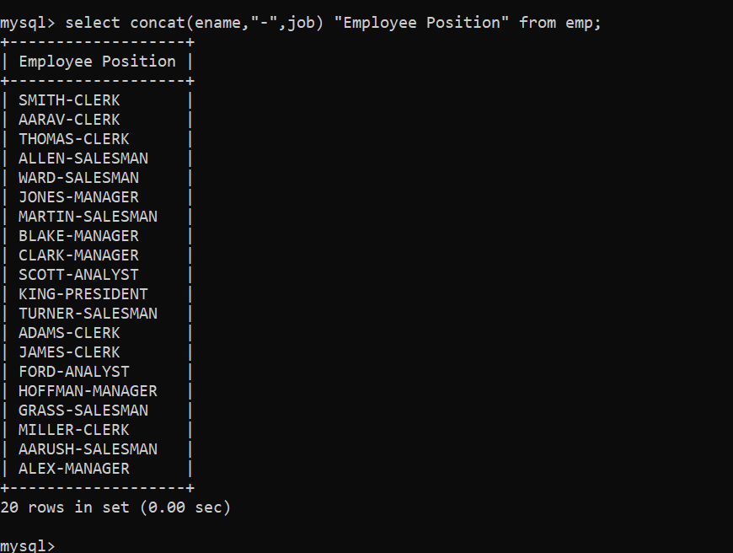

1. *Show the length of names in EMP table. Eliminate duplicate length. Do not show the names.*

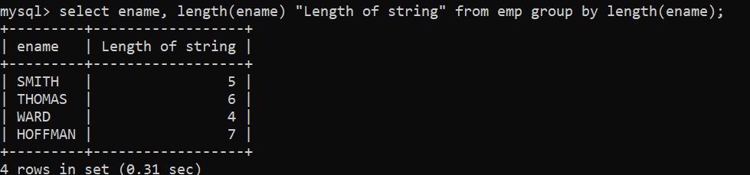

1. *List the names and hiredate of EMP in dept 20, display hiredate formatted as 12/03/1984.*

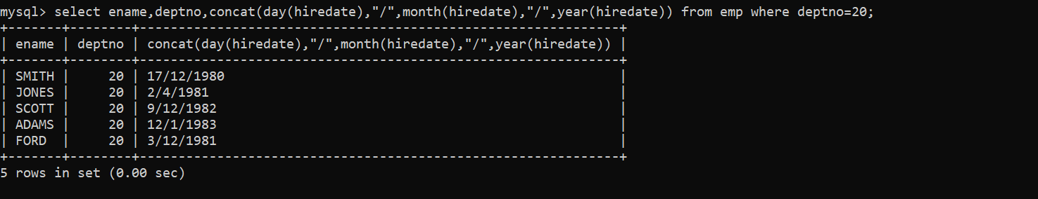

1. *Find the day of week on which SMITH joined.*

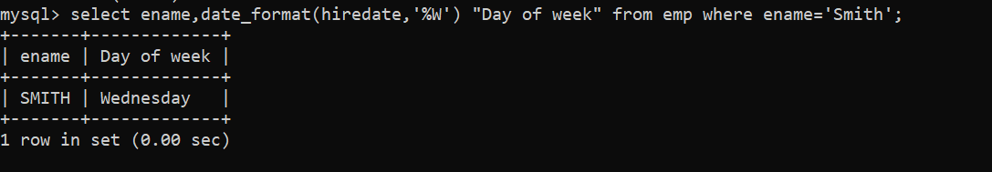

1. *Retrieve the ANALYST record with hiredate formatted as ‘The 3rd of Oct. 1984’.*



1. *Calculate the total compensation expensive for each dept in 1 year. Assume that employees, who don't earn commission, receive non-monetary benefits than are worth Rs.1000 a month.*
2. *Display the Names of the Managers as follows-*
3. *If the employee code is 7788 the Manager is CLARK*
4. *If the employee code is 7698 the Manager is BLAKE*
5. *If the employee code is 7566 the Manager is JONES*
6. *For all other Employees the Manager is KING*

